**R.V. COLLEGE OF ENGINEERING,**

**BANGALORE-560059**

**(Autonomous Institution Affiliated to VTU, Belgaum)**



Development and Application Of Concussion Sensors

MEMS Accelerometers

##### SELF STUDY REPORT

###### Submitted by **Vasishta Hd** USN No.1RV13IT058

**IV SEM**

**Dr. Prasanna Kumar ,Deepashree Devraj, Mr Kendagannaswamy, Mr MRS , Dr CH Renumadhavi**

**Department of Instrumentation Technology, R V College of Engineering**

Submitted to

**DEPARTMENT OF INSTRUMENTATION TECHNOLOGY**

**R.V. COLLEGE OF ENGINEERING, BANGALORE - 560059**

**(Autonomous Institution Affiliated to VTU, Belgaum)**

**CONTENTS**

|  |  |  |
| --- | --- | --- |
| **Serial No** | **Topic** | **Page No** |
| 1) | Introduction | 2 |
| 2) | Literature Survey | 3 |
| 3) | Motivation | 4 |
| 4) | Problem Statement | 4 |
| 5)  6) | Objectives  Methodology | 5  5 |
| 7) | Budgets and other Financials | 10 |
| 8) | Institutions working on Concussion Sensors | 10 |
| 9) | Conclusion | 11 |

**INTRODUCTION**

**Concussion**, from the [Latin](http://en.wikipedia.org/wiki/Latin) *concutere* ("to shake violently")[[1]](http://en.wikipedia.org/wiki/Concussion#cite_note-Pearce-1) or *concussus* ("action of striking together"),is the most common type of [traumatic brain injury](http://en.wikipedia.org/wiki/Traumatic_brain_injury). Frequently defined as a [head injury](http://en.wikipedia.org/wiki/Head_injury) with a temporary loss of [brain function](http://en.wikipedia.org/wiki/Brain_function), concussion causes a variety of physical, [cognitive](http://en.wikipedia.org/wiki/Cognition), and emotional symptoms, which may not be recognized if subtle.

Treatment involves monitoring as well as physical and cognitive rest (reduction of such activities as school work, playing video games and text messaging). Symptoms usually resolve within three weeks, though they may persist or complications may occur.

Those who have had one concussion seem more susceptible to another, especially if the new injury occurs before symptoms from the previous concussion have completely resolved. There is also a negative progressive process in which smaller impacts cause the same symptom severity. Repeated concussions may increase the risk in later life for dementia, Parkinson's disease, and/or depression.

A variety of signs accompany concussion including somatic (such as headache), cognitive (such as feeling in a fog), emotional (such as emotional changeability), physical signs (such as loss of consciousness or amnesia), behavioral changes (such as irritability), cognitive impairment (such as slowed reaction times), and/or sleep disturbances. A 2010 *Pediatrics* review article focusing on children and adolescents noted that fewer than 10% of sports-related concussions had associated loss of consciousness.

Due to varying definitions and possible underreporting, the rate at which concussion occurs annually is not accurately known, but is estimated to be more than 6 per 1,000 people. Common causes include [sports injuries](http://en.wikipedia.org/wiki/Concussions_in_sport), bicycle accidents, car accidents, and falls, the latter two being the most frequent causes among adults. In addition to a blow to the head, concussion may be caused by [acceleration](http://en.wikipedia.org/wiki/Acceleration) forces without a direct impact, and on the battlefield, MTBI is a potential consequence of nearby explosions.

It is not known whether the brain in concussion is structurally damaged or whether there is mainly a loss of function with only [physiological](http://en.wikipedia.org/wiki/Physiology) changes. Cellular damage has reportedly been found in concussed brains, but it may have been due to [artefacts](http://en.wikipedia.org/wiki/X-ray_computed_tomography#Artifacts) from the studies. It is currently thought that structural and [neuropsychiatric](http://en.wikipedia.org/wiki/Neuropsychiatry) factors may both be responsible for the effects of concussion.

# Literature Survey

1. ***"Estimating Energy Expenditure Using Body-Worn Accelerometers***": A Comparison of Methods ,Sensors Number and Positioning by Marco Altini, Julien Penders, Ruud Vullers, and Oliver Amft at the IEEE JOURNAL OF BIOMEDICAL AND HEALTH INFORMATICS, VOL. 19, NO. 1, JANUARY 2015-
   * They compare three prevalent EE estimation methods and five body locations to provide a basis for selecting among methods, sensors number, and positioning(2015).
2. ***"A high sensitivity micromachined accelerometer with an enhanced inertial mass SOI MEMS process"*** by XIE Jianbing, SONG Meng, YUAN Weizheng from Micro and Nano Electromechanical Systems Laboratory, Northwestern Polytechnical University, Xi’an, China (2014)
   * This paper provides an enhanced inertial mass SOI MEMS process for the fabrication of a high sensitivity micromachined accelerometer.
3. ***" Security in Wireless Sensor Networks for Health Monitoring Helmet with Anomaly Detection using Power Analysis and Probabilistic Model "*** by Biswajit Panja ,Zachary Scott University of Michigan-Flint, MI 48502 at the 2014 IEEE Conference on Wireless Sensors (ICWiSE), October, 26-28 2014, Subang, Malaysia
   * This article proposes a system that uses a modification of the AESCCM protocol as well as a novel attack detection system that uses probabilistic methods to report any harmful behavior to the user
4. ***"3-AXIS ACCELERATION SWITCH FOR TRAUMATIC BRAIN INJURY EARLY WARNING"*** *by L. J. Currano1, C. R. Becker1, G. L. Smith1, B. Isaacson2, and C. J. morris1 from* 1U.S. Army Research Laboratory – U.S.A. 2General Technical Services (for ARL) – U .S.A.
   * This paper reports on the design, fabrication, and testing of a 3-axis acceleration switch intended to serve as an early warning for traumatic brain injury (TBI)

# Motivation

***"A Compact Sensor System for Concussion Mitigation in Helmets – A Concept Prototype"***

by Veena Divya K, Deepashree Devaraj, Rajasree PM and Anmol Oberoi -The Department of Instrumentation Technology, R.V. College of Engineering, Bangalore, India.

This paper presents a concept approach towards the detection of level of impacts to head, in a helmet and understands the severity of impact through signal processing technique. This System gives an indication though a LED and communicates to the emergency contacts fed to the GSM through wireless communication. Hence, the time needed for action is less as comparable to the existing methodology.

The article suggests for further work in the development of more energy efficient through self energy generation techniques. Development and fabrication of better sensors is also suggested.

**Problem Statement**

The simple wearable devices are used by normal people while jogging, running and other applications where the users look at the display to notice the measured values of the sensors. The sensors are set to predetermined threshold limit so that other activities do not initiate the control chain. We have to implement the same with better **concussion sensor**.

If the device has the feature of wireless data transmitting capability, the data can be sent to a central station through a transceiver. Most of the data are stored, processed in the computer. Depending on the requirements, the results may be available through an access of a website from a remote place. The monitoring system may consists of many sensors are integrated .the data collected can be graphical displayed to make the diagnosis **easier and more comfortable**.

The system consists of other sensors integrated as well as accelerometers to give the overall picture. All the measured physiological data are collected by a microcontroller to process and analyze .The controller transmits the data to a server via coordinators like zigbee, in between. The sever detects threat if any and initiates an automatic response system .The response system may include entities like doctors , hospitals, government , military etc. Data may be stored for further **research and future medical reference**.

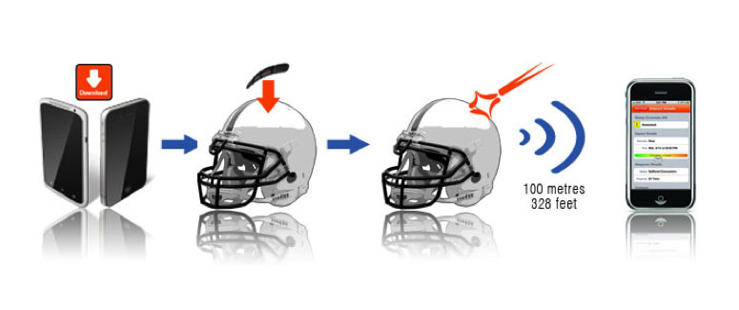

### working of a sports concussion SENsing helmet

**Objectives**

Our objectives is to develop a **concussion sensor** system that is **compact and energy efficient**  that can placed inside the helmet . Any force applied is detected by the sensor and then passed on the signal using the microcontroller . The signal received should be transmitted to the sever. Further , processing the signal and the response.

Our work will be mainly focussed on the **development and application** of accelerometer that is cheap , energy efficient , accurate and reliable . This involves fabrication of acceleration switches taking into account the general working of the **MEM accelerometer**

**Methodology**



# Here for the implementation of the sensor , we can use ADXL335 accelerometer sensor. For the controller- open source Arduino microcontrollers series.HC-05 Bluetooth module for transmission. All of these can be interfaced with a computer or a Smartphone to give the indication when needed.

**MEMS Accelerometer**

An accelerometer is an electromechanical device that is used to [**measure acceleration**](http://www.instrumentationtoday.com/acceleration-transducer/2011/08/) and the [**force**](http://www.instrumentationtoday.com/force-transducers/2011/07/) producing it. Even today, one of the most commonly used one is the [**piezoelectric**](http://www.instrumentationtoday.com/piezoelectric-transducer/2011/07/)accelerometer. But, since they are bulky and cannot be used for all operations, a smaller and highly functional device like the MEMS accelerometer was developed. Though the first of its kind was developed 25 years ago, it was not accepted until lately, when there was need for large volume industrial applications. Due to its small size and robust sensing feature, they are further developed to obtain multi-axis sensing.

**Working**

One of the most commonly used MEMS accelerometer is the capacitive type. The capacitive MEMS accelerometer is famous for its high sensitivity and its accuracy at high temperatures. The device does not change values depending on the base materials used and depends only on the capacitive value that occurs due to the change in distance between the plates. Capacitive accelerometers typically use a silicon micro-machined sensing element. Their performance is superior in the low frequency range and they can be operated in [servo](http://en.wikipedia.org/wiki/Servomechanism) mode to achieve high stability and linearity.

If two plates are kept parallel to each other and are separated by a distance ‘d’, and if ‘E’ is the permittivity of the separating material, then capacitance produced can be written as

**C0 = E0.E A/d = EA/d EA= E0EA** where ,A – Area of the electrodes

***[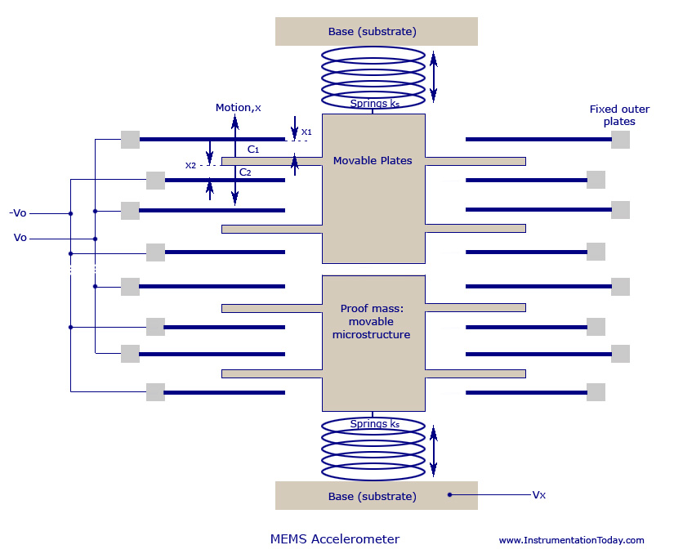](http://www.instrumentationtoday.com/wp-content/uploads/2011/08/MEMS-Accelerometer.jpg)[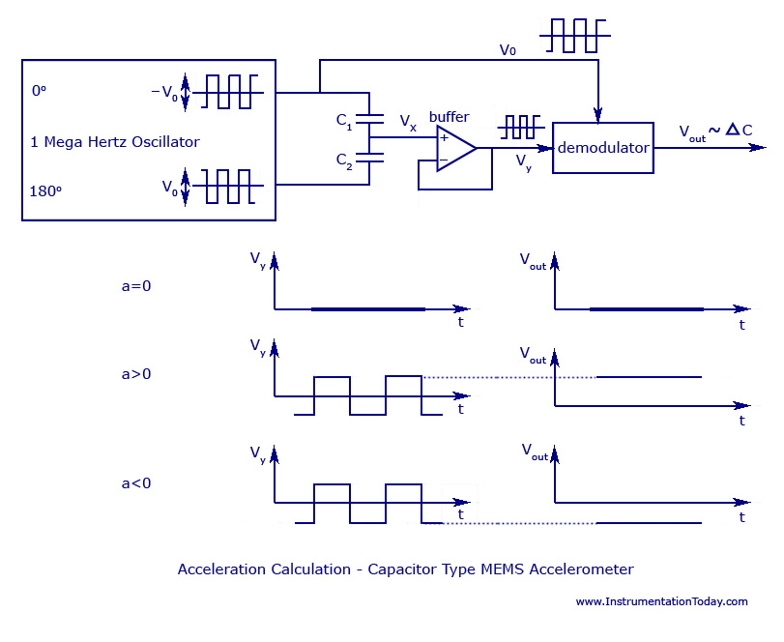](http://www.instrumentationtoday.com/wp-content/uploads/2011/08/Capacitor-Type-MEMS-Accelerometer.jpg)***

***Capacitor Type MEMS Accelerometer***

A change in the values of E, A or d will help in finding the change in capacitance and thus helps in the working of the MEMS transducer. Accelerometer values mainly depend on the change of values of d or A.

A typical MEMS accelerometer is shown in the figure below. It can also be called a simple one-axis accelerometer. If more sets of capacitors are kept in 90 degrees to each other you can design 2 or 3-axis accelerometer. A simple MEMS transducer mainly consists of a movable microstructure or a proof mass that is connected to a mechanical suspension system and thus on to a reference frame.

The movable plates and the fixed outer plates act as the capacitor plates. When acceleration is applied, the proof mass moves accordingly. This produces a capacitance between the movable and the fixed outer plates.

When acceleration is applied, the distance between the two plates displace as X1 and X2, and they turn out to be a function of the capacitance produced.

From the image above it is clear that all sensors have multiple capacitor sets. All upper capacitors are wired parallel to produce an overall capacitance C1 and the lower ones produce an overall capacitance of C2.

If V**x** is the output voltage of the proof mass, and V**0**is the output voltage produced between the plates, then : **(Vx+V0) C1 + (Vx-V0) C2 = 0**

We can also write: **Vx=V0[(C2-C1)/(C2+C1)] = (x/d) V0**

The figure below shows the circuit that is used to calculate the acceleration, through change in distance between capacitor plates. The output obtained for different values of acceleration is also shown graphically. When no acceleration is given (a=0), the output voltage will also be zero. When acceleration is given, such as (a>0), the value of value of V**x** changes in proportion to the value of V**0**.When a deceleration is given, such as (a<0), the signals V**x** and V**y** become negative. The demodulator produces an output equal to the sign of the acceleration, as it multiplies both the values of V**y** and V**0** to produce V**OUT**, which has the correct acceleration sign and correct amplitude.

The length of the distance, d and the proof mass weigh is surprisingly very small. The proof mass weighs no more than 0.1 microgram and the output capacitance is approximately 20 aF and the plate distance is no more than 1.3 micrometers.

**Specifications of a suitable accelerometer - ADXL335:**

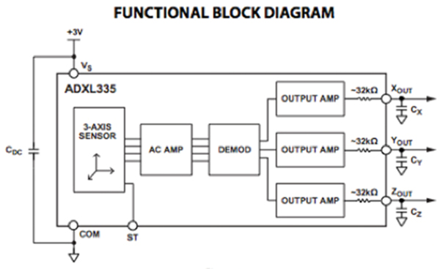

 A popular accelerometer for use in sports ad health devices is the [ADXL335](http://www.digikey.com/product-detail/en/ADXL335BCPZ-RL7/ADXL335BCPZ-RL7TR-ND/1995480) three-axis accelerometer from Analog Devices. The ADXL335 is a small, thin, low power, complete three-axis accelerometer with signal conditioned voltage outputs.

The product measures acceleration with a minimum full-scale range of ±3 g and can measure the static acceleration of gravity in tilt-sensing applications, as well as dynamic acceleration resulting from motion, shock, or vibration.

The user selects the bandwidth of the accelerometer to suit the application with a range of 0.5 to 1,600 Hz for the x and y-axes, and a range of 0.5 to 550 Hz for the z axis.

The ADXL335 is available in a small, low-profile, 4 × 4 × 1.45 mm, 16-lead, plastic lead-frame chip-scale package .

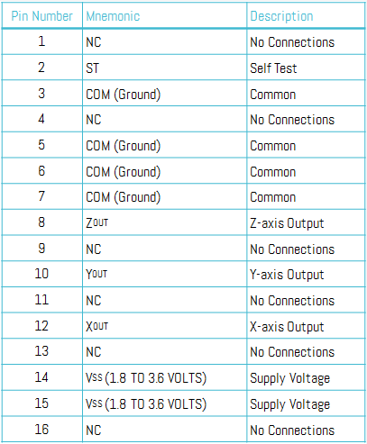

**Budget and other financials:**

* The National Football League could spend more than $914 million to settle claims brought by former players over head injuries, according to a proposed agreement submitted for court approval.
* The sensors, which retail for $149.99, are being used on hockey, football, snow sport and lacrosse helmets.
* market price of "brain sentry impact counter plus" - >$75.00
* The main market not only involves athletes but also students, construction workers and military.

**Our model:**

* Cost Of accelerometer sensor ADXL335 -Rs 250
* Controller -Arduino Uno :Rs 750
* Bluetooth Module : Rs 600
* Other Fabrication cost : Rs200 -Rs500
* Total Cost :Rs 1800-Rs 2100

**Institutions working on Concussion Sensors**

* Organisations like National Football league ,USA fund research in this area.
* Companies like "Head case" , "Shock Box ", "Jolt " ,"Brain Sentry " , "X2 Biosystems", "Battle Sports" and "CheckLight" are into research , development and manufacture of concussion related products
* Research organisations like [American Academy of Neurology](https://www.aan.com/) ,[Michigan NeuroSport Program](http://www.uofmhealth.org/medical-services/brain-neurological-conditions/concussion) are also working in this domain

**Conclusion**

The current technology is highly implementable. Future work include by development of sensors of greater accuracy by use of newer technologies such as nanotechnology. Better processing of data has to done. The system can also be designed to predict the exact effect of the impact. This can be by developed by using the data collected from the previous readings and developing the algorithms to analyse the same.

By making the sensors more wearable, this technology can be implemented more easily in the army as well as common motorists. Flexible electronics, integrating sensors in textiles , should be done. Other applications include construction workers, security personnel, mine workers ,etc.

Other technologies can also be integrated such as power development using the athlete's motion .We can also optimize power consumption by selecting low power transmitting modules such as Zigbee and Bluetooth. By using Bluetooth , the existing smart phones itself can be used.

A immediate response system should be designed for critical cases .A cloud service which directly initiates the concerned Doctor and hospital can also be thought of. This not only gives immediate help but also helps for future analysis of the results for research as well as patient health purposes.

**References:**

* *"Estimating Energy Expenditure Using Body-Worn Accelerometers*": A Comparison of Methods ,Sensors Number and Positioning by Marco Altini, Julien Penders, Ruud Vullers, and Oliver Amft at the IEEE JOURNAL OF BIOMEDICAL AND HEALTH INFORMATICS, VOL. 19, NO. 1, JANUARY 2015
* *"A high sensitivity micromachined accelerometer with an enhanced inertial mass SOI MEMS process"* by XIE Jianbing, SONG Meng, YUAN Weizheng from Micro and Nano Electromechanical Systems Laboratory, Northwestern Polytechnical University, Xi’an, China (2014)
* *" Security in Wireless Sensor Networks for Health Monitoring Helmet with Anomaly Detection using Power Analysis and Probabilistic Model "* by Biswajit Panja ,Zachary Scott University of Michigan-Flint, MI 48502 at the 2014 IEEE Conference on Wireless Sensors (ICWiSE), October, 26-28 2014, Subang, Malaysia
* *"3-AXIS ACCELERATION SWITCH FOR TRAUMATIC BRAIN INJURY EARLY WARNING" by L. J. Currano1, C. R. Becker1, G. L. Smith1, B. Isaacson2, and C. J. morris1 from* 1U.S. Army Research Laboratory – U.S.A. 2General Technical Services (for ARL) – U .S.A.
* M. S. Muller, T. C. Buck, H. J. El-Khozondar, and A. W. Koch, “Shear Strain Influence on Fiber Bragg Grating Measurement Systems,” *J. Light. Technol.*, vol. 27, no. 23, pp. 5223–5229, Dec. 2009. Petchprapai N, Winkelman C (2011).
* S. Javdani, M. Fabian, M. Ams, J. Carlton, T. Sun, and K. T. V. Grattan, “Fiber Bragg Grating-Based System for 2-D Analysis of Vibrational Modes of a Steel Propeller Blade,” *J. Light. Technol.*, vol. 32, no. 23, pp. 3991–3997, Dec. 2014 Palmer J.W, Bing K.F, Sharma A.C, Greneker E.F.
* ‘DetectingConcussion Impairment with Radar Using Gait Analysis Techniques’.Radar Conference (RADAR), 2011 IEEE. Page(s): 222 - 225 , Publication Year: 2011 . Slobounov S, Sebastianelli W, Newell K.M.’ Incorporating Virtual Reality Graphics with Brain Imaging for Assessment of Sport-Related Concussions’
* wwwsparkfun.com/datasheets/Components/SMD/adxl335.pdf
* https://www.google.co.in/url?sa=t&rct=j&q=&esrc=s&source=web&cd=8&cad=rja&uact=8&sqi=2&ved=0CEgQFjAH&url=http%3A%2F%2Fwww.nlm.nih.gov%2Fmedlineplus%2Fconcussion.html&ei=dIjmVP3KJsfIuATCmIKIAg&usg=AFQjCNFIkNdTLM9HQKzUIqB9V3EeOQy0Mg